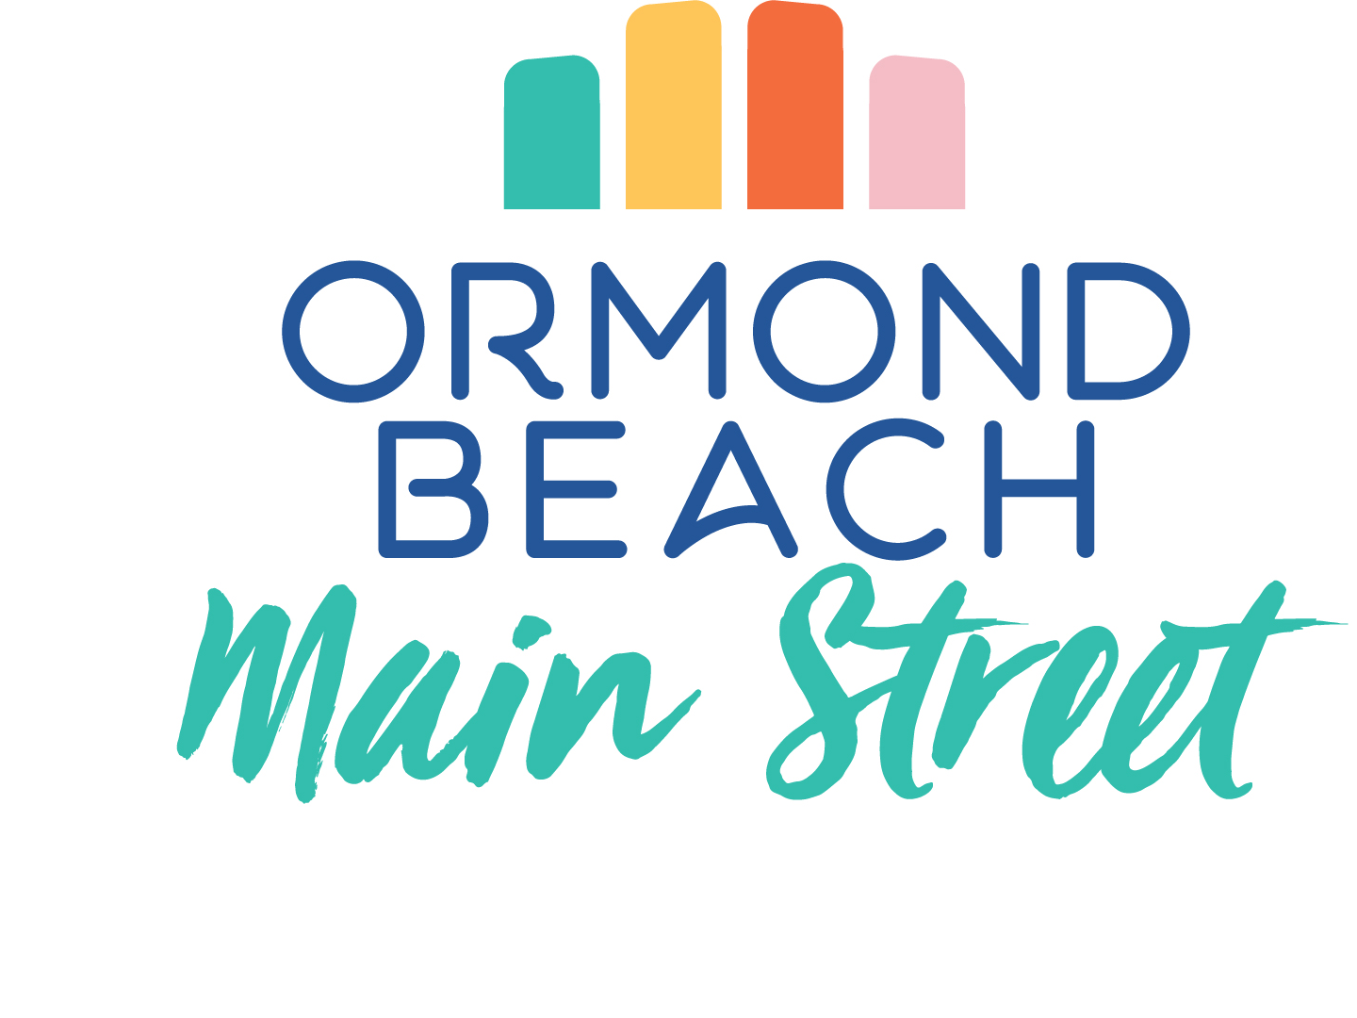
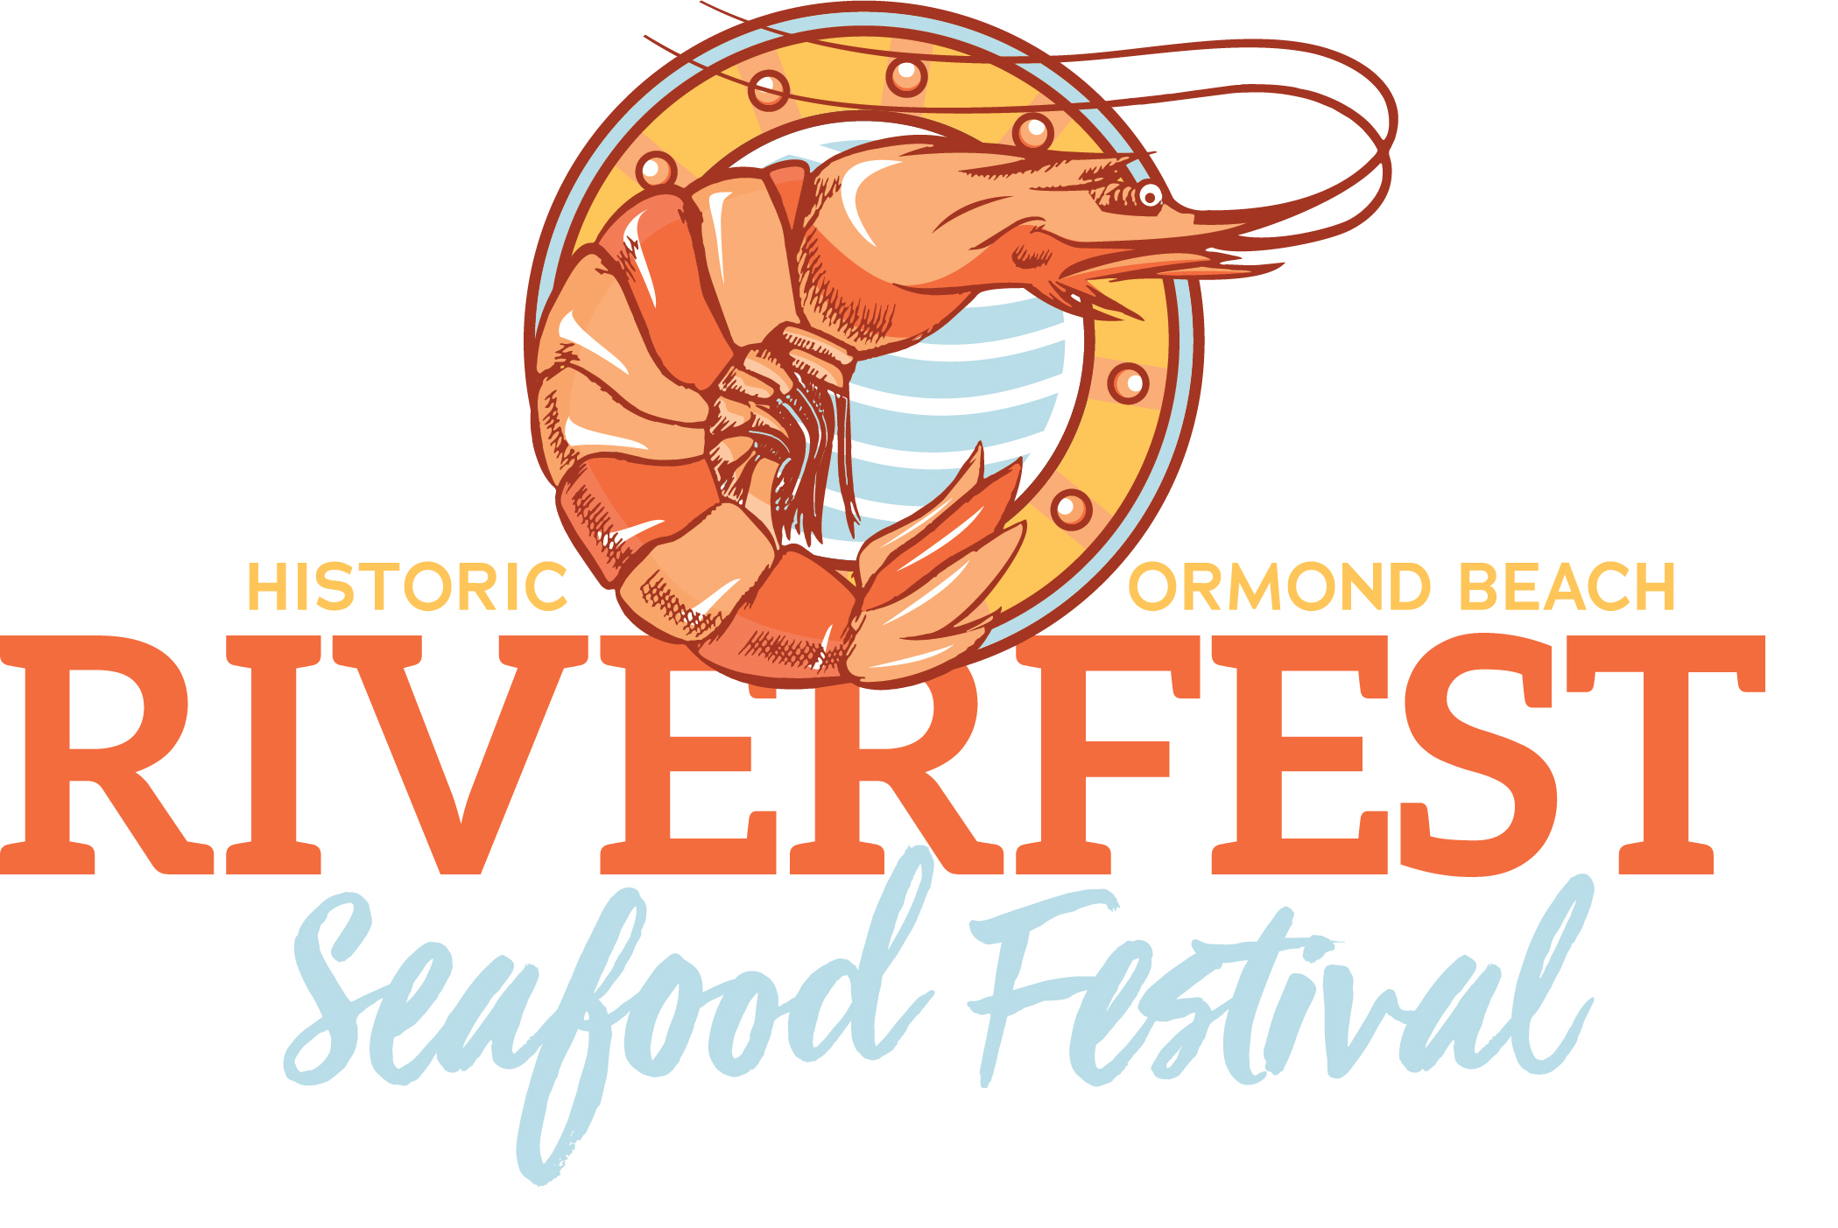
Riverfest Seafood Festival
November 20-21, 2021

RIVERFEST “FAST FACTS”

- FREE admission!
- Celebrating our 11th Year
- 13,000 + attendees
- FB Page – 35,000+ Followers
- Boat and Recreation Display, free boat rides
- Scheduled activities all weekend
- Beautiful Location - Halifax River
- Continuous live music all weekend
- Endless Family Activities - Kid's Zone, Putt-Putt, Water Balls, Face Painting, bouncy houses, bungees, crafts, pirate ship, & more!
- FREE Kid's Fishing clinic and fishing pole giveaway (while supplies last)
- Live chef demonstrations, food & wine pairings
- Pub area live streaming college and pro football games
- Organized by community Non-Profit organization

Presenting Sponsor - $8,000 (1 Available)
- Exclusivity by business sponsor (we will not feature competitive companies at event)
- Premier location of 10 x 10 on-site booth space (includes electric; tent, table and 2 chairs), promotion of services & products
- Prominent signage at gate and throughout Festival (up to 7 banners)
- Presenting Sponsor of event in all media releases, television ads, radio spots, publicity posters, magazine ads/articles, brochures, flyers, web site, and follow-up public relations materials PLUS ad in program
- Presenting sponsor and logo exposure on all promotional billboards, banners
- Stand-alone logo inclusion and link to company website in electronic communications (e-newsletters, OMS website, social media announcements 40,000+ followers, etc.)
- 10 x 10 branded booth space in premiere location to be used for entertaining and/or promoting the company’s goods & services. VIP Parking.
- Recognition as presenting sponsor in PA announcements every hour per day
- One year Ormond Mainstreet membership AND year-round promotion of your
- Company logo included on Festival T-shirt

Main Stage Sponsor - $5,000 (1 Available)
- Main Stage named for your company
- Large company banner to hang in front of music main stage and subsequent banners (up to 4) throughout festival
- 10 x 10 on-site booth space (includes electric; tent, table and 2 chairs), promotion of services & products
- Recognition in all pre and post event media releases
- Large logo inclusion and link to company website in electronic communications (e-newsletters, OMS website, social media announcements 40,000+ followers, etc.)
- PA announcements recognizing stage sponsor before each performance
- Large Logo inclusion on all print materials (posters, flyers, maps), billboards, banners
- One year Ormond Mainstreet membership
- Company logo included on Festival T-shirt

Waterfront Sponsorship - $3,000 (can be shared between up to two companies)
- Archway signage at both Fortunato Park entrances (John Anderson and The Casements)
- Recognition in all pre and post event media releases
- Logo inclusion on all print materials (posters, flyers, maps)
- Large inclusion and link to company website in electronic communications (e-newsletters, OMS website, social media announcements, etc.)
- 10 x 10 branded booth space to be used for entertaining and/or promoting the company’s goods & services in featured location for both days of Festival.
- Recognition as presenting sponsor in at least three PA announcements per day
- One year Ormond Mainstreet membership
- Company logo included on Festival T-shirt

Casements Sponsor - $2,000 (can be shared between up to two companies)
- Chef Demonstrations stage named for your company, company banner to hang at stage
- Logo inclusion on all print materials (flyers, maps, posters, etc.)
- Logo inclusion in electronic communications (e-newsletters, OMS website, social media announcements, etc.)
- Recognition as Casements Sponsor in at least 4 PA announcement per day
- One year Ormond Mainstreet membership
- Company logo included on Festival T-shirt

Kid’s Zone Sponsor - $1,000 (1 available)
- Kid’s Zone named for your company (i.e. “business name” Kid’s Zone)
- Large company signage at Kid’s Zone entrance
- Logo inclusion on all print materials (flyers, maps, posters, etc.)
- PA announcements from main stage recognizing Kid’s Zone sponsor

Entertainment Sponsor - $500 (4 Available)
- Company banner hung from main stage tent seating area
- Recognition on all print materials, social media, and Riverfest t-shirt
- PA announcements from main stage

Golf-Cart Sponsor - $500 (2 Available)
- Company banner over hood of golf carts driven continuously throughout festival

Banner Sponsor - $250 (Unlimited)
- Company banner displayed in high-traffic area at event

We are happy build a custom sponsorship level to fit your needs and budget, and welcome sponsorships greater than $10,000. Annual sponsorships available. Please contact Becky Parker, Event Coordinator, Ormond Mainstreet at 386-492-2938.

