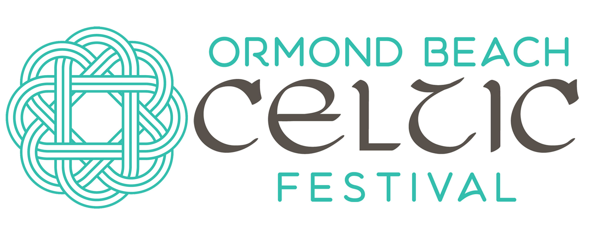
The 10th Annual
April 18-19, 2020

September 11-12, 2021

CLAN NAME: _________________________________________________________________________________________________
NAME OF APPLICANT: ______________________________________________________________________________________
ADDRESS: ____________________________________________________________________________________________________
EMAIL: ________________________________________________________________________________________________________
PHONE: _______________________________________________________________________________________________________
WEBSITE: _____________________________________________________________________________________________________
HAVE YOU ATTENDED IN THE PAST? WHAT YEAR(S)?: _________________________________________________
SPECIAL REQUESTS___________________________________________________________________________________________
There is a $25 reservation fee per clan. Please include your fee with this application.
We consider clans an integral part of our festival. Each clan will receive 5 free admission bracelets for the weekend ($100 Value). You will need your own fire retardant tent and set up (tables, chairs, etc). You are welcome to promote or fund raise as you wish. We ask that NO OPEN liquids of any kind be given away or sold due to health department and similar regulations. Set up is Friday, September 10, 2021 from 9am to 5pm, the earlier the better. Tear down is Sunday, September 12 at the close of the Festival. Clans are asked to be present at the festival BOTH days
Schedule of Events:
Friday, September 10, 2021 – 9:00 am to 5:00 pm setup
Friday, Sept, 10, 2021 – 7:00 pm Festival Kick-off party/ Jam session -Fletcher’s Irish Pub (393 W. Granada Blvd)
Saturday, September 11, 2021 – 10 am to 7 pm - Ormond Beach Celtic Festival, Rockefeller Gardens
Join us at Fletcher’s Irish Pub for a Festival After-party!
Sunday, September 12, 2021 – 11 am to 5 pm Ormond Beach Celtic Festival, Rockefeller Gardens
20+ Celtic performers and dancers continuously entertaining on 5 stages! Highland Games! Jam Tent and Workshop! All are welcome!! Kirkin' o' the Tartan, honored clan celebrations, dog parade, and more! Celtic Vendors and Food….Kid’s Games and Crafts…..Beer/Wine Garden….Something for EVERYONE!
Be sure to follow and share the Ormond Beach Celtic Festival Facebook Page!
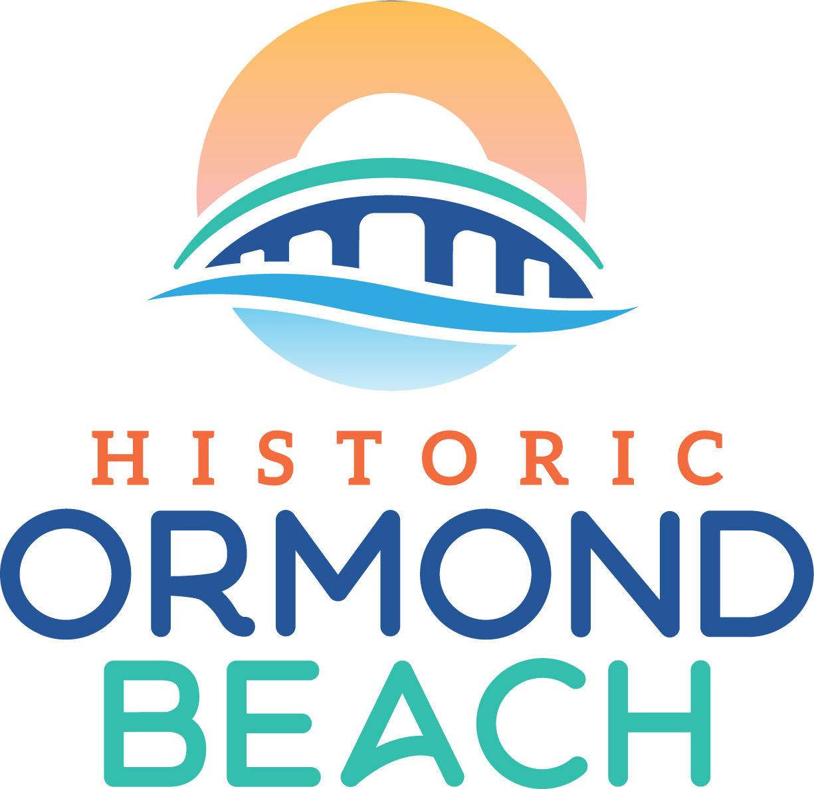
Correspondence regarding further details and event guidelines to follow. Please mail or email your application to:
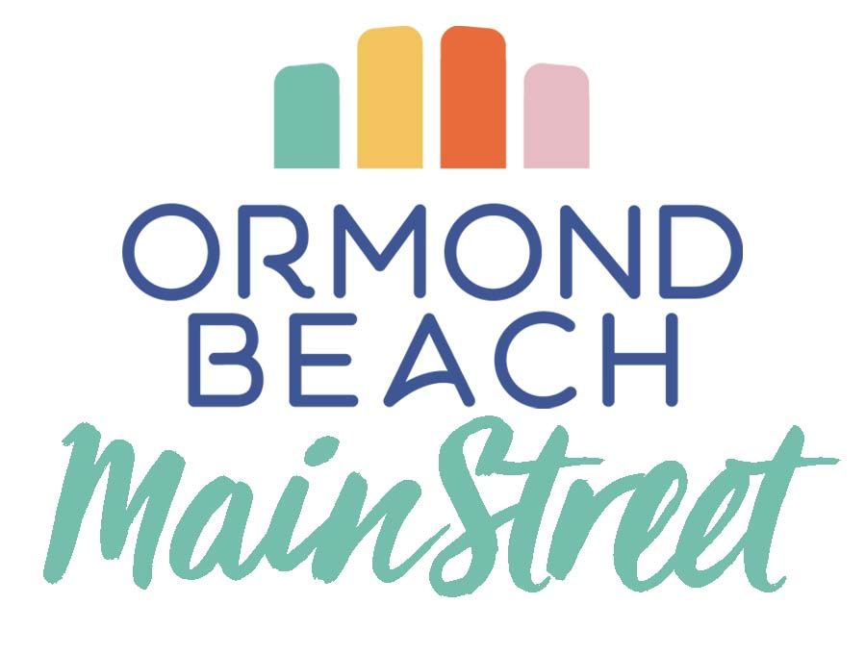
Becky Parker * Ormond MainStreet, Inc. * PO Box 2917 * Ormond Beach, FL 32175
Phone: 386-492-2938 | Email: Becky@ormondmainstreet.com
www.OrmondBeachCelticFestival.com

